**PCB DESIGNING PROCESS**

The printed circuit board manufacturing process is a very difficult and complex process.  
**Patterning | Etching :**

Majority of printed circuit boards are manufactured by applying a layer of copper over the entire surface of the PCB substrate either on one side or both sides. This creates a blank printed circuit board, with the copper everywhere on the surface. From here the unwanted copper is removed by subtractive methods.

**Photoengraving :**

The photoengraving process uses a mask or photomask combined with chemical etching to subtract the copper areas from the circuit board substrate.   
The photomask is created with a photoplotter which takes the design from a CAD PCB software program. Lower resolution photomasks are sometimes created with the use of a laser printer using a transparency.  
**Lamination:**

 Many printed circuit boards are made up of multiple layers; these are referred to as multi-layer printed circuit boards. They consist of several thin etched boards or trace layers and are bonded together through the process of lamination.

Before etching

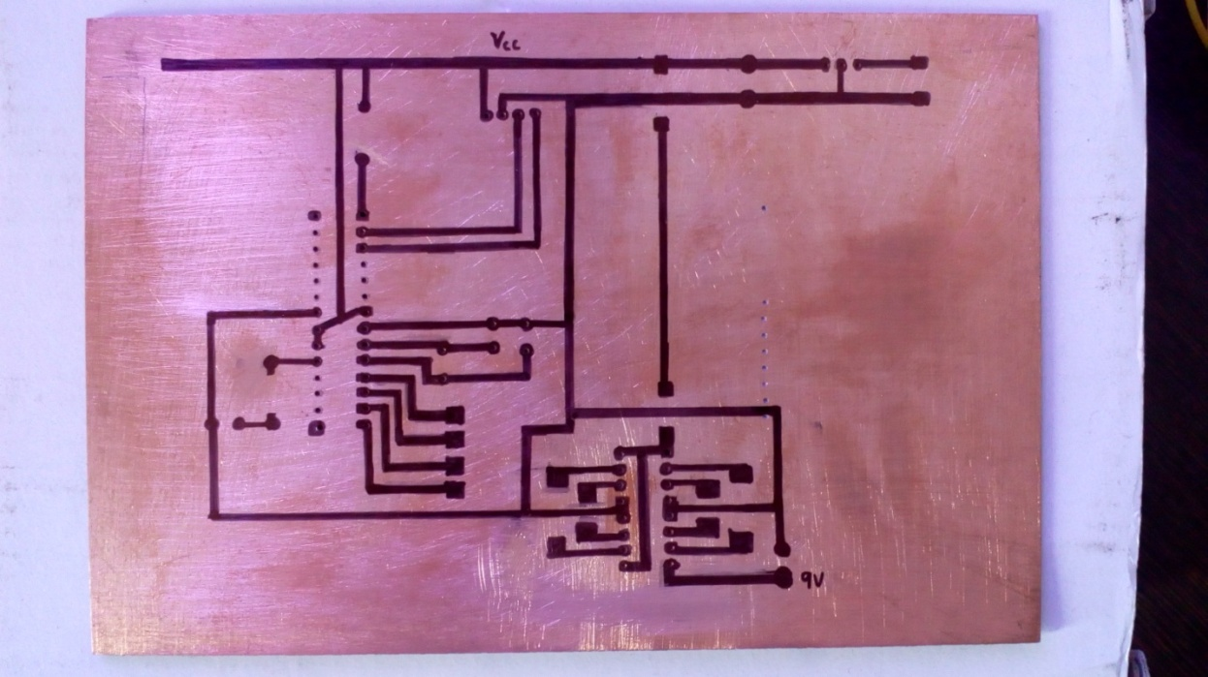

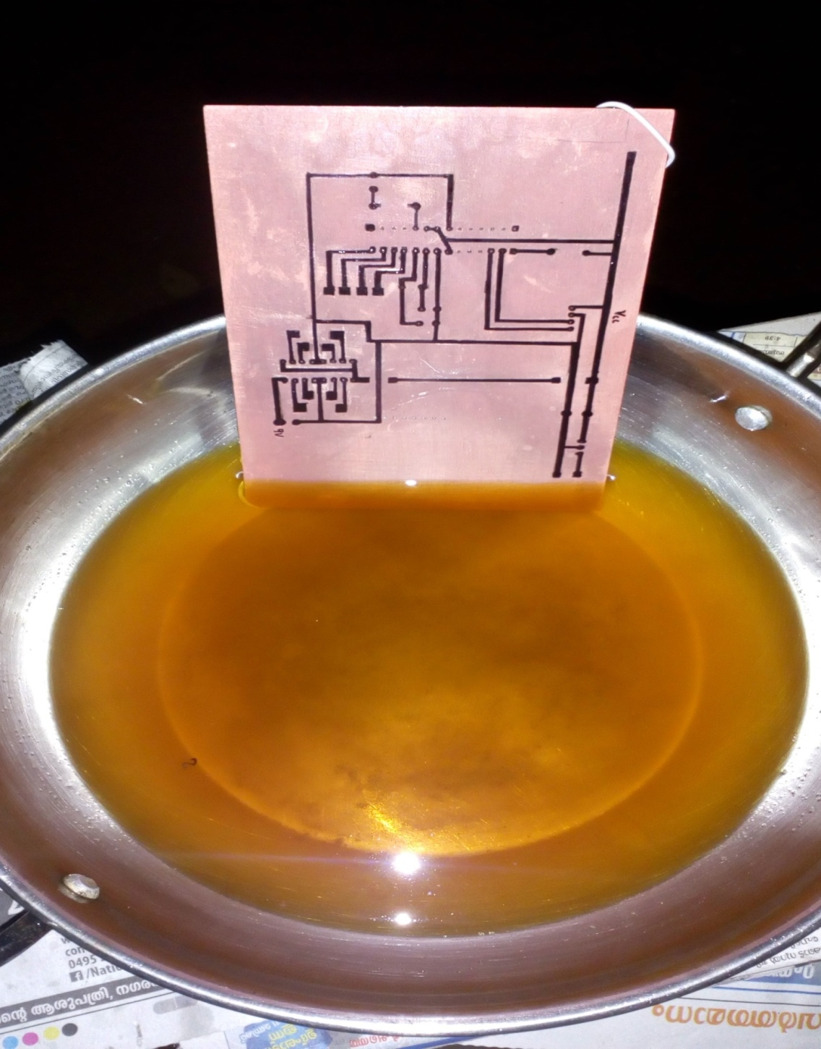

**After Etching**

